EXPT NO:2 | Implementation of data visualization techniques
DATE: 06.01.2026 | Implementation of data visualization techniques

PRE-LAB QUESTIONS (PROVIDE BRIEF ANSWERS TO THE FOLLOWING QUESTIONS)
1.Why is exploratory data analysis critical before model building?
Exploratory Data Analysis (EDA) helps understand data patterns, detect missing values and outliers, and identify relationships between variables, ensuring better model selection and performance.
2.How do distributions influence algorithm selection in ML?
Data distribution affects algorithm choice because some models assume normality or linearity, while others handle skewed or non-linear data better.
3.What insights can outliers provide in business data?
Outliers may indicate errors, fraud, rare events, or high-value customers, helping businesses identify risks and opportunities.
4.Why are visual summaries preferred over raw tables?
Visual summaries quickly reveal trends, patterns, and anomalies, making data easier to interpret than raw numerical tables.
5.How does visualization improve business intelligence?
Visualization enables faster decision-making by presenting complex data in an intuitive form, helping stakeholders identify insights and performance gaps efficiently.
IN-LAB EXERCISE:
OBJECTIVE:

To explore data distribution and variability using advanced visualization techniques.
SCENARIO:
A startup analyzes e-commerce transaction data to understand customer spending behavior and detect abnormal purchase patterns.

IN-LAB TASKS (Using R Language)
1.Plot histogram of transaction amounts
Code:

install.packages("lubridate")
install.packages("reshape2")

library(ggplot2)
library(dplyr)
library(lubridate)
library(reshape2)
data <- read.csv("C:\\Users\\mohan\\Downloads\\2.ecommerce_transactions.csv")

head(data)

ggplot(data, aes(x = Transaction_Amount)) +
geom_histogram(
binwidth = 500,
fill = "steelblue",
color = "black"
) +
labs(
title = "Histogram of Transaction Amounts",
x = "Transaction Amount",
y = "Frequency"
) +
theme_minimal()

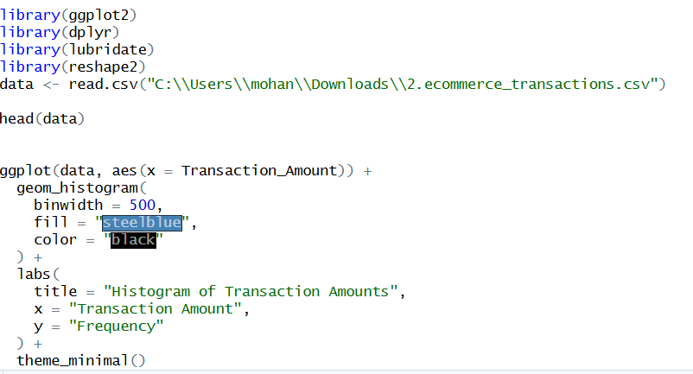

Output:
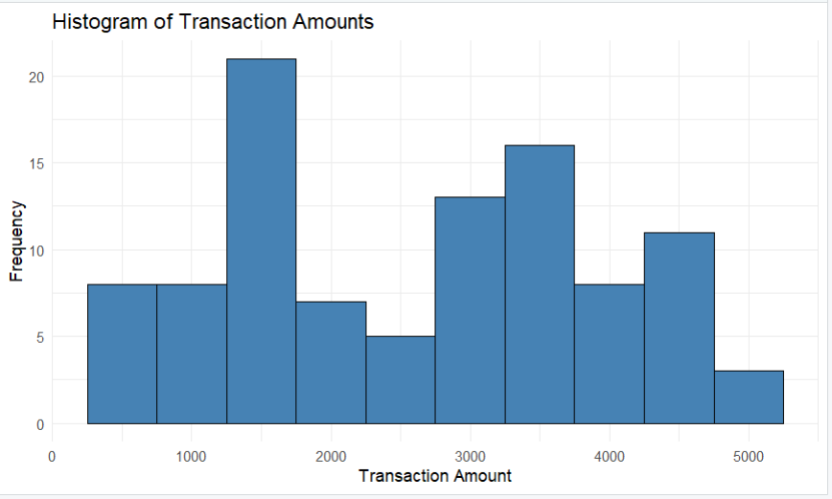

2.Use boxplot to detect outliers

Code:

ggplot(data, aes(y = TransactionAmount)) +
geom_boxplot(
fill = "orange",
outlier.color = "red",
outlier.size = 2
) +
labs(
title = "Boxplot of Transaction Amounts",
y = "Transaction Amount"
) +
theme_minimal()
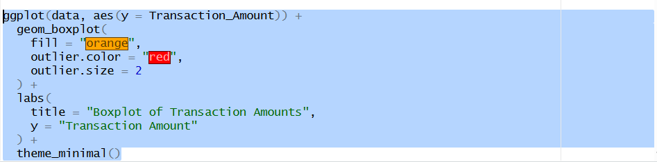

Output:

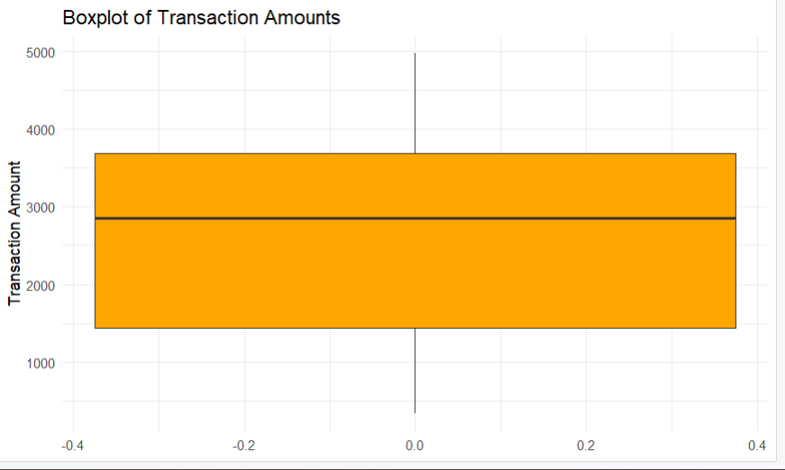

3.Create heatmap of monthly sales intensity
Code:

library(dplyr)
library(lubridate)
library(ggplot2)

data$Transaction_Date <- as.Date(data$Transaction_Date)

# Extract Month and Year
data$Month <- format(data$Transaction_Date, "%b")
data$Year <- format(data$Transaction_Date, "%Y")

monthly_sales <- data %>%
group_by(Month, Year) %>%
summarise(
TotalSales = sum(Transaction_Amount),
.groups = "drop"
)

ggplot(monthly_sales, aes(x = Year, y = Month, fill = TotalSales)) +
geom_tile(color = "white") +
scale_fill_gradient(low = "lightblue", high = "darkred") +
labs(
title = "Heatmap of Monthly Sales Intensity",
x = "Year",
y = "Month"
) +
theme_minimal()
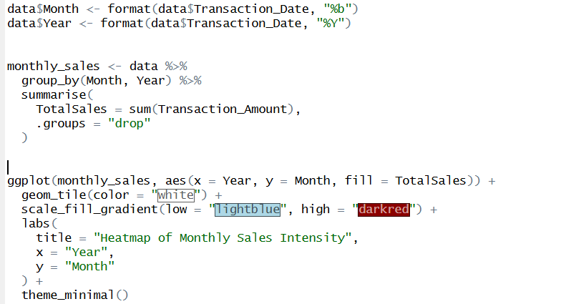

Output:

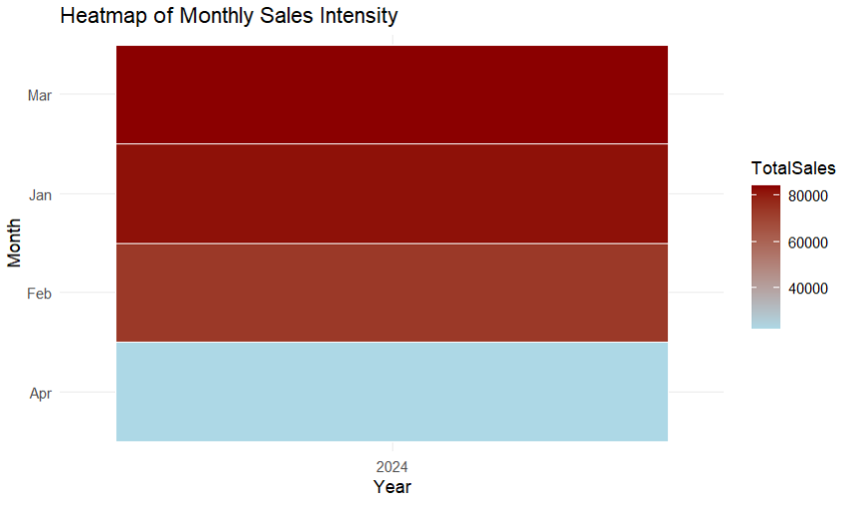

POST-LAB QUESTIONS (PROVIDE BRIEF ANSWERS TO THE FOLLOWING QUESTIONS)
1.What does right-skewed distribution indicate about customer behavior?

A right-skewed distribution shows that most customers make low or medium-value purchases. A small number of customers make very high-value transactions. These customers significantly increase total revenue. This pattern is common in e-commerce sales data.

2.How can detected outliers impact business decisions?

Outliers can represent fraud, data entry errors, or high-value customers. Identifying them helps businesses reduce risk and improve data quality. Outliers can also indicate special customer segments. Proper handling leads to better strategic decisions.

3.Which visualization best supports anomaly detection?

Boxplots are best for anomaly detection as they clearly highlight outliers beyond the normal data range. They make it easy to compare distributions. Extreme values are visually separated from regular data points. This helps in quick analysis.

4.How does EDA improve AI model accuracy?

EDA helps identify missing values, outliers, and data distributions before training models. It ensures proper data cleaning and transformation. This reduces noise and bias in the dataset. As a result, model performance improves.

5.How can visualization guide feature engineering?

Visualizations reveal relationships between variables and patterns in the data. They help identify important features and remove irrelevant ones. Trends and correlations guide the creation of new meaningful features. This improves model effectiveness.

ASSESSMENT
Description | Max Marks | Marks Awarded
Pre Lab Exercise | 5
In Lab Exercise | 10
Post Lab Exercise | 5
Viva | 10
Total | 30
Faculty Signature

